# Lab: Methods

Problems for in-class lab for the ["Programming Fundamentals and Unit Testing" course @ SoftUni](https://softuni.bg/trainings/4256/programming-fundamentals-and-unit-testing-september-2023)  
You can check your solutions in [Judge](https://judge.softuni.org/Contests/4348)

## Grades

In this task, you will **implement a method** **that receives** a grade between **2.00** and **6.00** and **print the corresponding grade definition**:

Create a method

* 2.00 – 2.99 - "**Fail**"
* 3.00 – 3.49 - "**Poor**"
* 3.50 – 4.49 - "**Good**"
* 4.50 – 5.49 - "**Very good**"
* 5.50 – 6.00 - "**Excellent**"
* In every other case - **"Grade is out of range"**

A single floating point number is given as an input from the console.

Your task is to complete the provided skeleton class **GradeProcessor** by implementing the **DefineGrade** method.

### Examples

|  |  |
| --- | --- |
| **Input** | **Output** |
| 3.33 | Poor |
| 4.50 | Very good |
| 2.99 | Fail |
| 6.01 | Grade is out of range |

### Hints

1. Read the grade from the console and pass it to a method

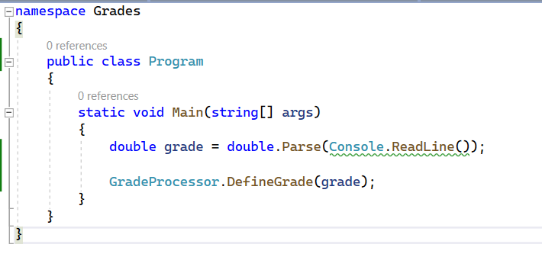

1. Then create the method and make the if statements for each case

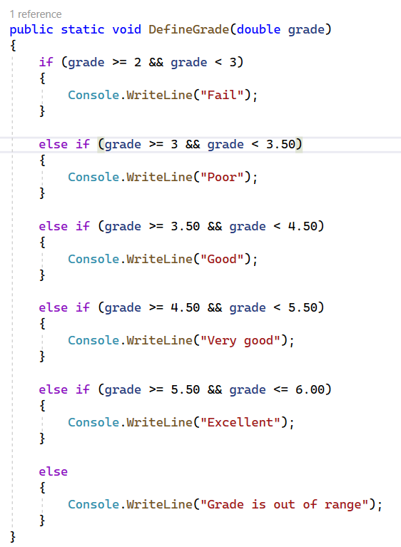

## Unit Testing Grades

In this task, you will practice unit testing by creating test cases for the **DefineGrade** method. You have already implemented the method that checks if a given grade is **Fail**, **Poor**, **Good**, **Very good**, **Excellent** or **Grade is out of range**. Now, your goal is to **ensure that this method works correctly** by writing **unit tests using NUnit**.